The TCP/IP Protocol Suite -

The TCP/IP model is the implemented model in the network communication, whereas the OSI model is just the reference model. The TCP/IP is used prior.

The TCP / IP consists of -

1. Application Layer.
2. Transport Layer.
3. Internet Layer.
4. Network Access Layer.

Application Layer - Represents the data to the user, involves encoding and dialogue control.

Transport Layer – Supports Communication between diverse devices across diverse networks.

Internet - Determines the best path through the network.

Network Access – Controls the hardware devices and media devices that make up the network.

TCP IP Protocol Suite

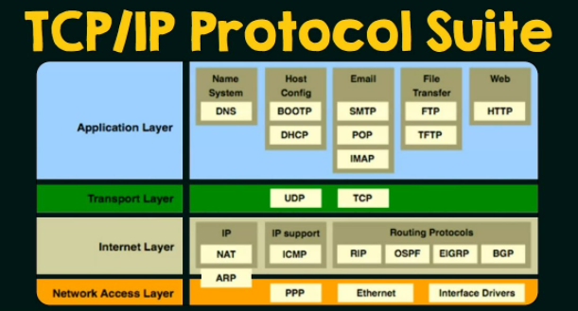

Network Access Layer - It consists of protocols like Point to Point Protocol (PPP), Ethernet Protocol and consists of Interface Drivers.

Internet Layer – It consists of IP Protocols like Network Address Translation(NAT), IP support Protocols like ICMP and Routing Protocols like RIP, BGP, OSPF.

Transport Layer – It consists of protocols like User Datagram Protocol (UDP) and Transmission Control Protocol (TCP). Any Application user either uses TCP or UDP protocol.

Application Layer – It consists of Name System Protocols which has Dynamic Name System (DNS),

Host Configuration Protocol as Bootstrap Protocol (BOOTP) and Dynamic Host Control Protocol (DHCP), Email Service Protocol as Simple Mail transfer (SMTP), Post Office Protocol (POP), Internet Message Access (IMAP), File Transfer Protocol as File Transfer Protocol (FTP),Trivial File Transfer Protocol (TFTP) and Web Services Protocol as Hyper Text Transfer Protocol (HTTP).

Protocol data Unit (PDU) -

Protocol data Units are named according to the segments of the TCP IP Protocol Suite - data, segment,

packets, frame and bits.

Application Layer - The information retrieved from the end user is called as Data.

Transport Layer - The Info/address of S & D once added to the Data from Application Layer, which engages with the Routers, is called as Segments.

Network Layer - The header added to the data from the Transport layer is called as the Packet.

Internet Layer -